PSP0201

Week 2

Writeup

Group Name: SupremeChickens

Members

|  |  |  |
| --- | --- | --- |
| **ID** | **Name** | **Role** |
| 1211103024 | Yap Jack | Leader |
| 1211102425 | Ang Hui Yee | Member |
| 1211101198 | Fam YI Qi | Member |
| 1211103978 | DIckshen | Member |

**Day 1: Web Exploitation – A Christmas Crisis**

**Tools used:** Kali Linux, Chrome

**Solution/walkthrough:**

Q1: Inspect the website. What is the title of the website?

A1: Christmas Console

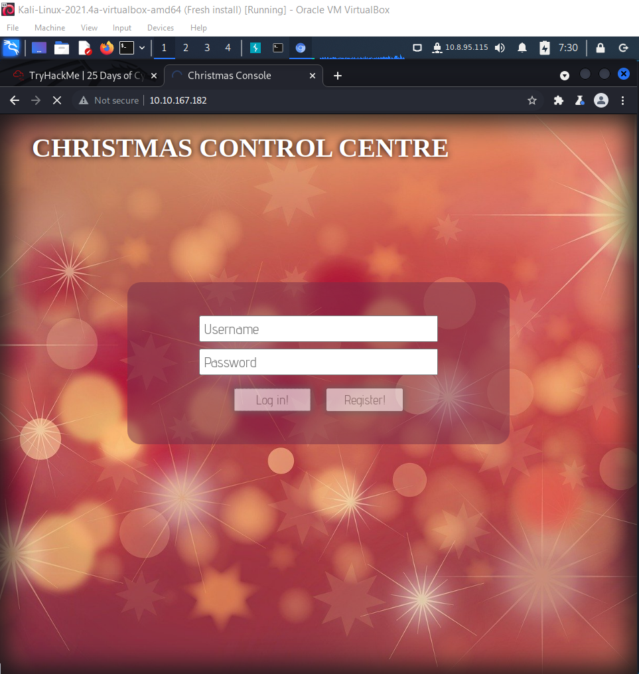

Q2: What is the name of the cookie used for authentication?

A2: auth

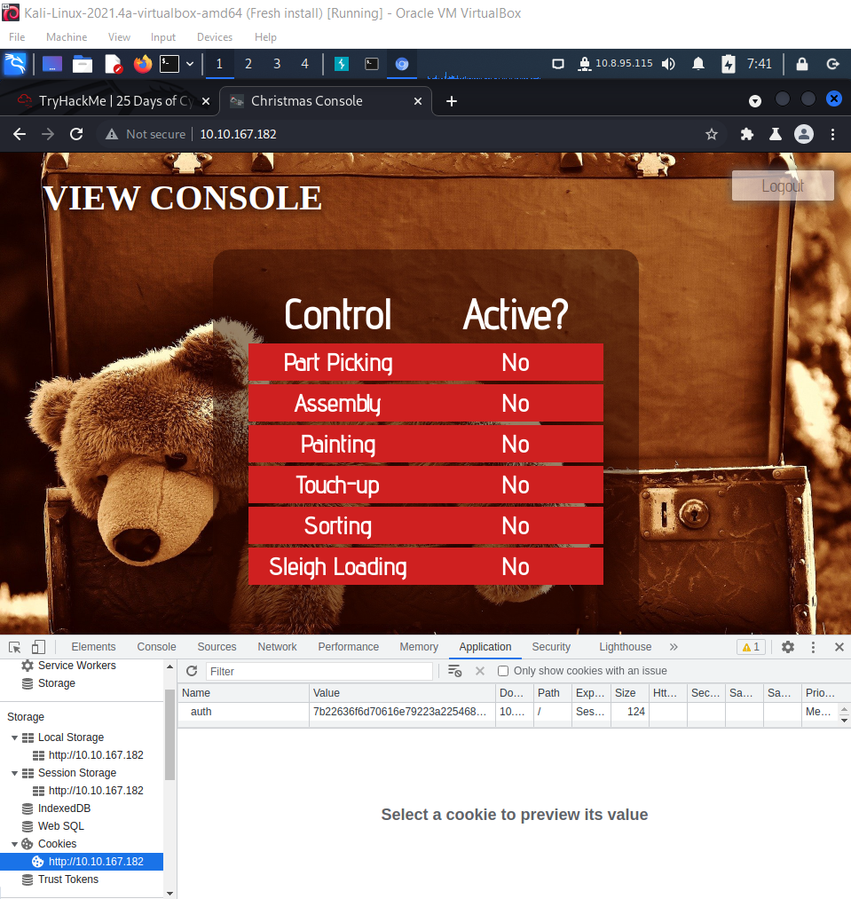

Q3: In what format is the value of this cookie encoded?

A3: Hexadecimal

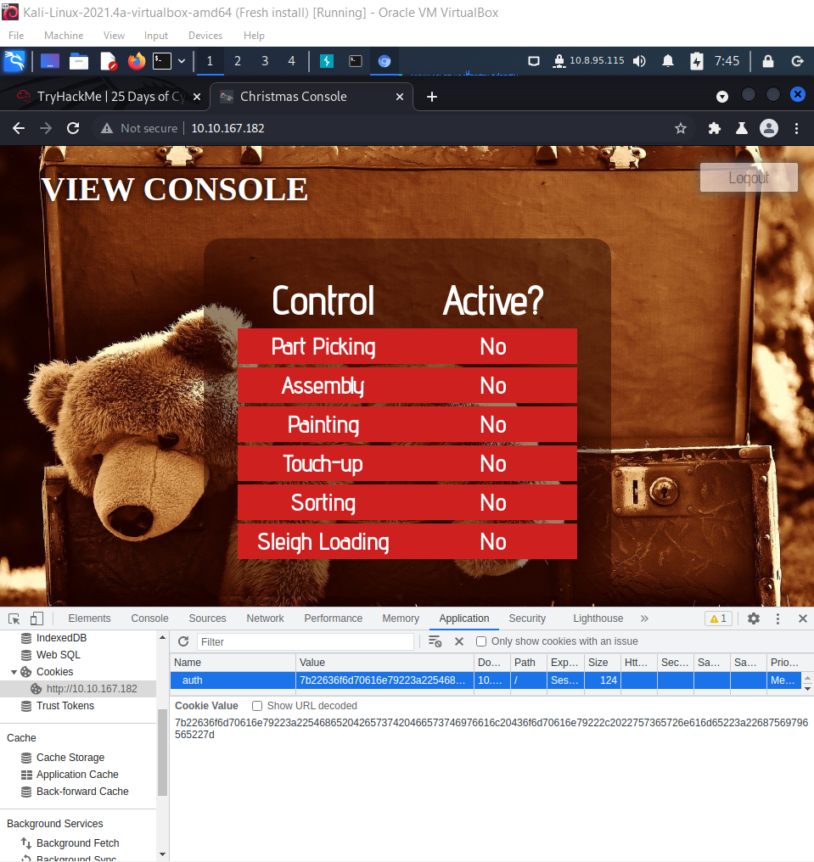

Q4: Having decoded the cookie, what format is the data stored in?

A4: JSON

Q5: What is the value for the company field in the cookie?

546865204265737420466573746976616c20436f6d70616e79

Q6: What is the other field found in the cookie?

A6: username

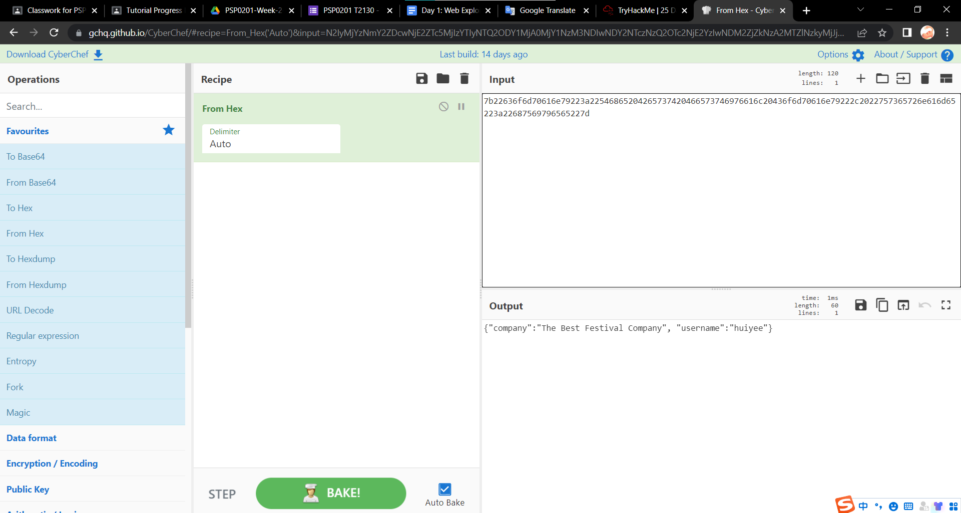

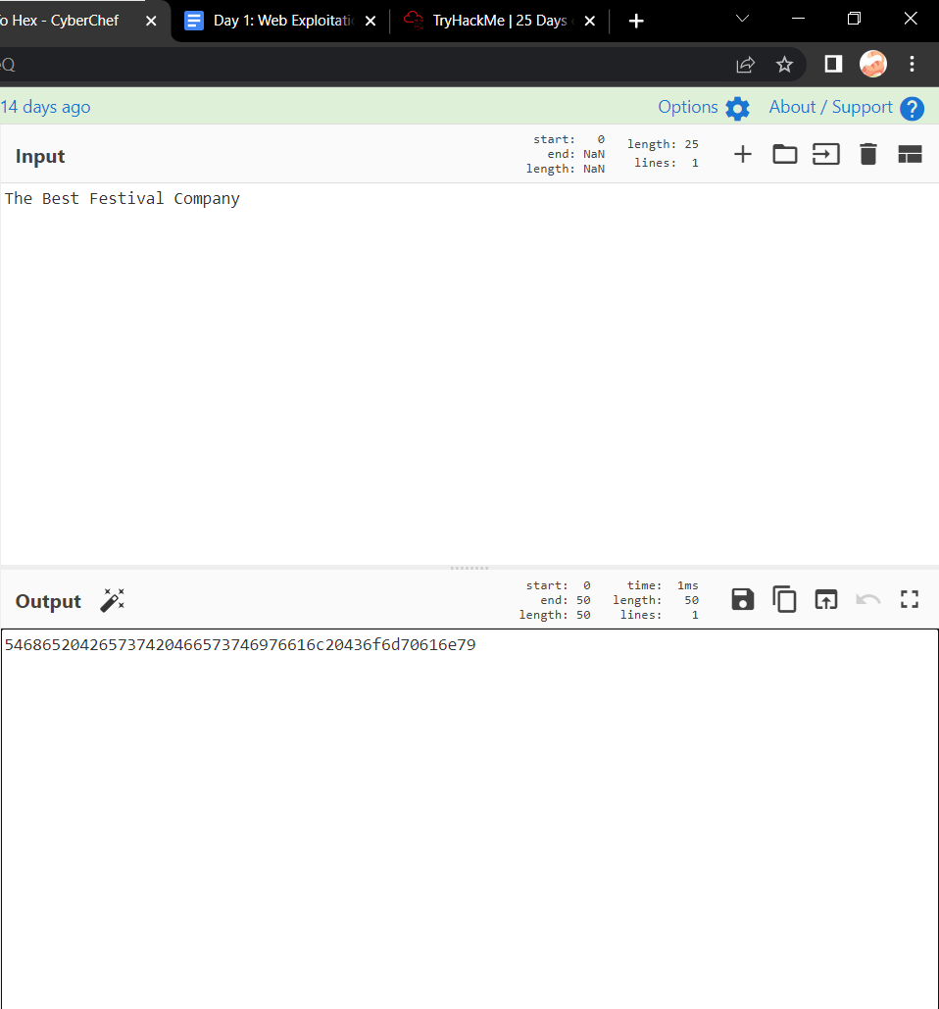

Q7: What is the value of Santa's cookie?

A7: 7b22636f6d70616e79223a22546865204265737420466573746976616c20436f6d 70616e79222c2022757365726e616d65223a2273616e7461227d

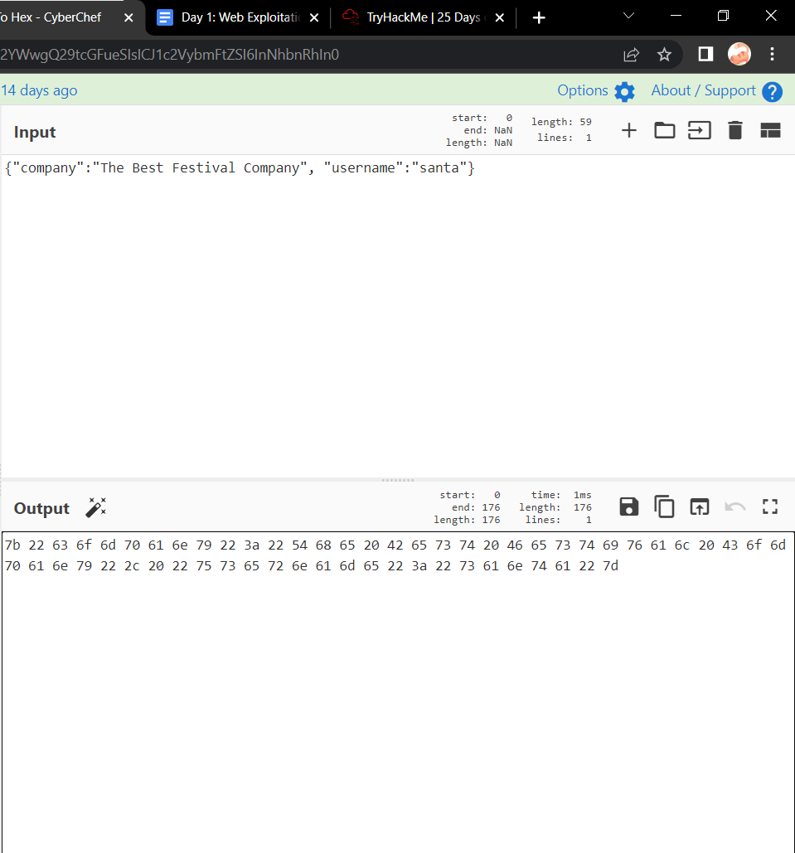

Q8: What is the flag you're given when the line is fully active?

THM{MjY0Yzg5NTJmY2Q1NzM1NjBmZWFhYmQy}

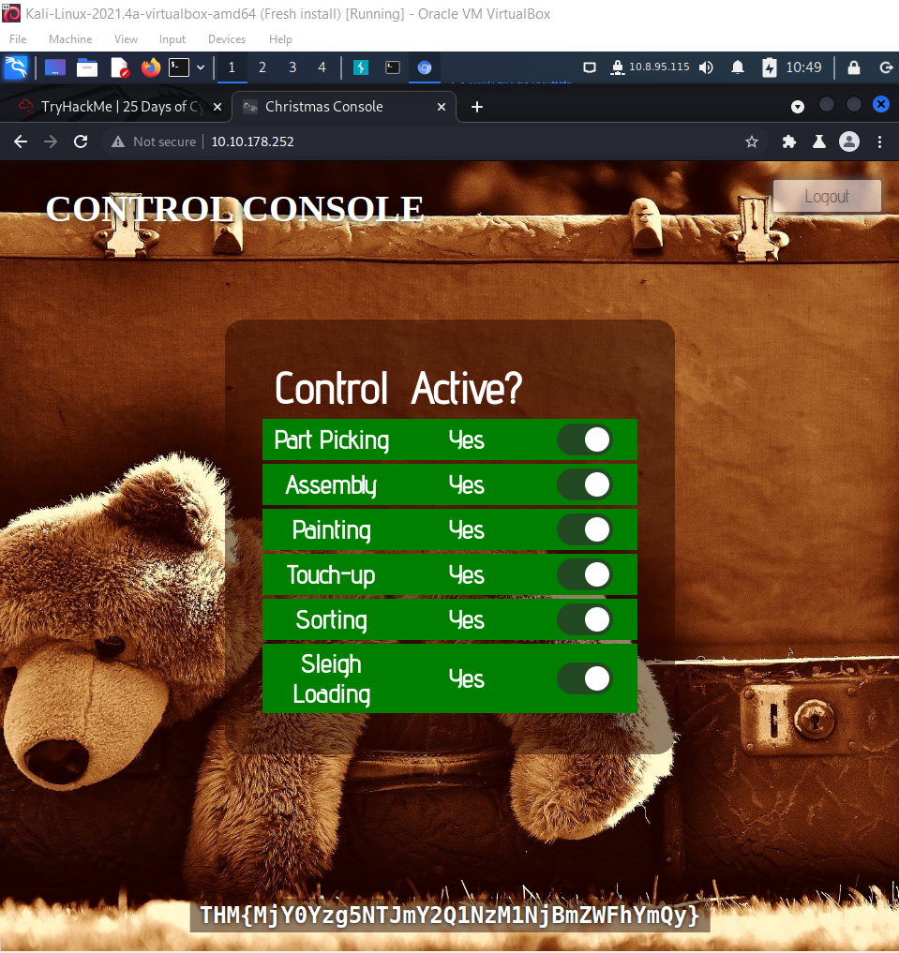

**Thought Process/Methodology:**

First, I access the target machine, and it shows me the title of the website. I register an account and log in. Then, I open the browser’s developer tool and choose the application to check the name of the cookie used for authentication. There is only one cookie. And I can see the name, value, etc. of the cookie. Afterwards, I go to CyberChef to decode the cookie value. I can see the company field in the cookie, and I use CyberChef to check the hexadecimal value of it. To know the value of Santa’s cookie, I change the username into Santa and use CyberChef to check the hexadecimal value of it. Then, I log out and back to the login page, I open the browser’s developer tool and go to the cookie page, and change the cookie name into ‘auth’, and change the value of the cookie. I successfully log into Santa’s account and active all the controls. I get a flag in the end.

**Day 2: Web Exploitation - The Elf Strikes Back!**

**Tools used:** Kali Linux, Chrome

**Solution/walkthrough:**

Q1: What string of text needs adding to the URL to get access to the upload page?

A1: ODIzODI5MTNiYmYw

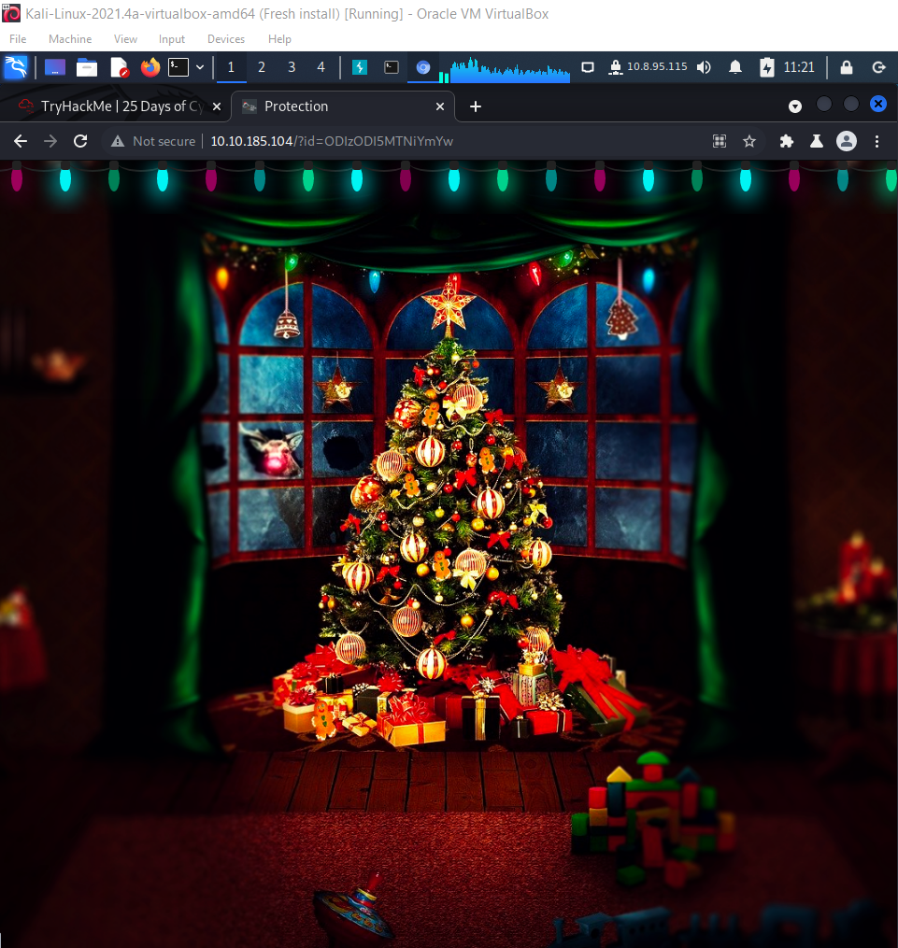

Q2: What type of file is accepted by the site?

A2: Image

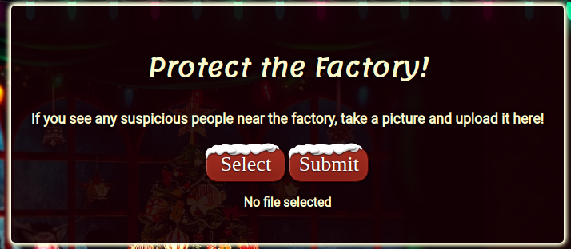

Q3: In which directory are the uploaded files stored?

uploads

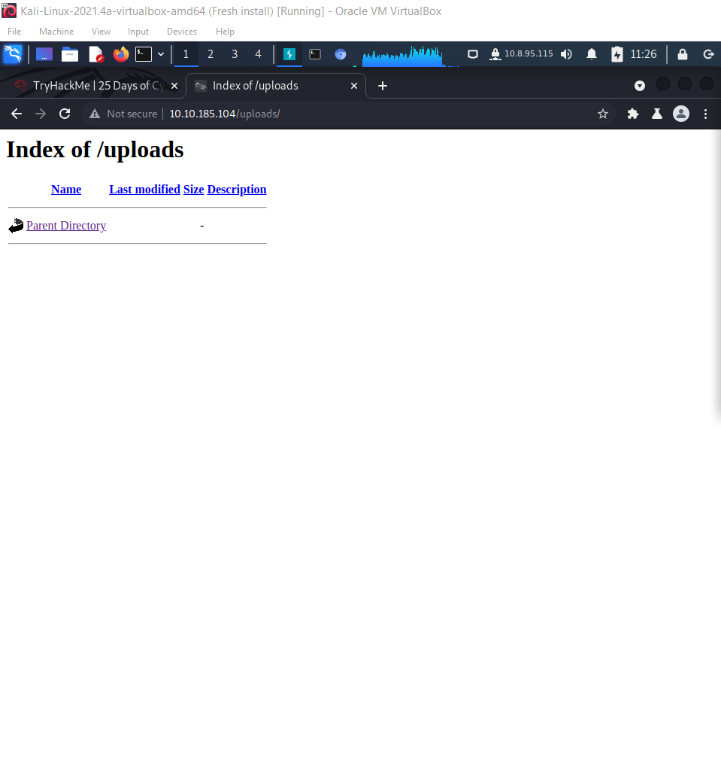

Q5: What is the flag in /var/www/flag.txt?

THM{MGU3Y2UyMGUwNjExYTY4NTAxOWJhMzhh}

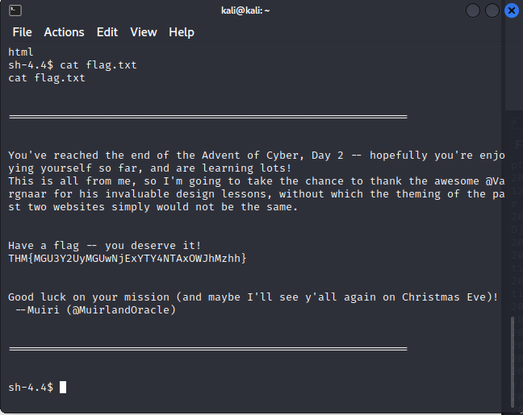

**Thought Process/Methodology:**

First, I access the target machine. I find that uploads are the uploaded files stored.

**Day 3: Web Exploitation - Christmas Chaos**

**Tools used:** Kali Linux, Chrome

**Solution/walkthrough:**

Q1: What is the name of the botnet mentioned in the text that was reported in 2018?

A1: Mirai

Q2: How much did Starbucks pay in USD for reporting default credentials according to the text?

A2: $250

Q3: Read the report from Hackerone ID:804548 - who was the agent assigned from the Dept of Defense that disclosed the report on Jun 25th?

A3: arm4nd0

Q4: Examine the options on FoxyProxy on Burp. What is the port number for Burp?

A4: 8080

Q5: Examine the options on FoxyProxy on Burp. What is the proxy type?

A5: HTTP

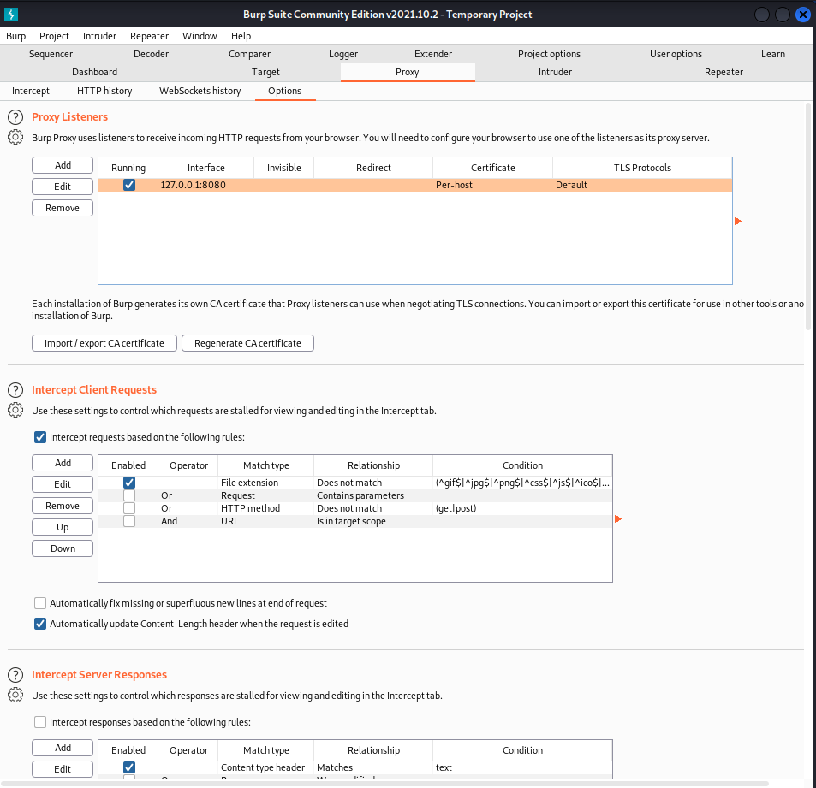

Q6: Experiment with decoder on Burp. What is the URL encoding for "PSP0201"?

A6: %50%53%50%30%32%30%31

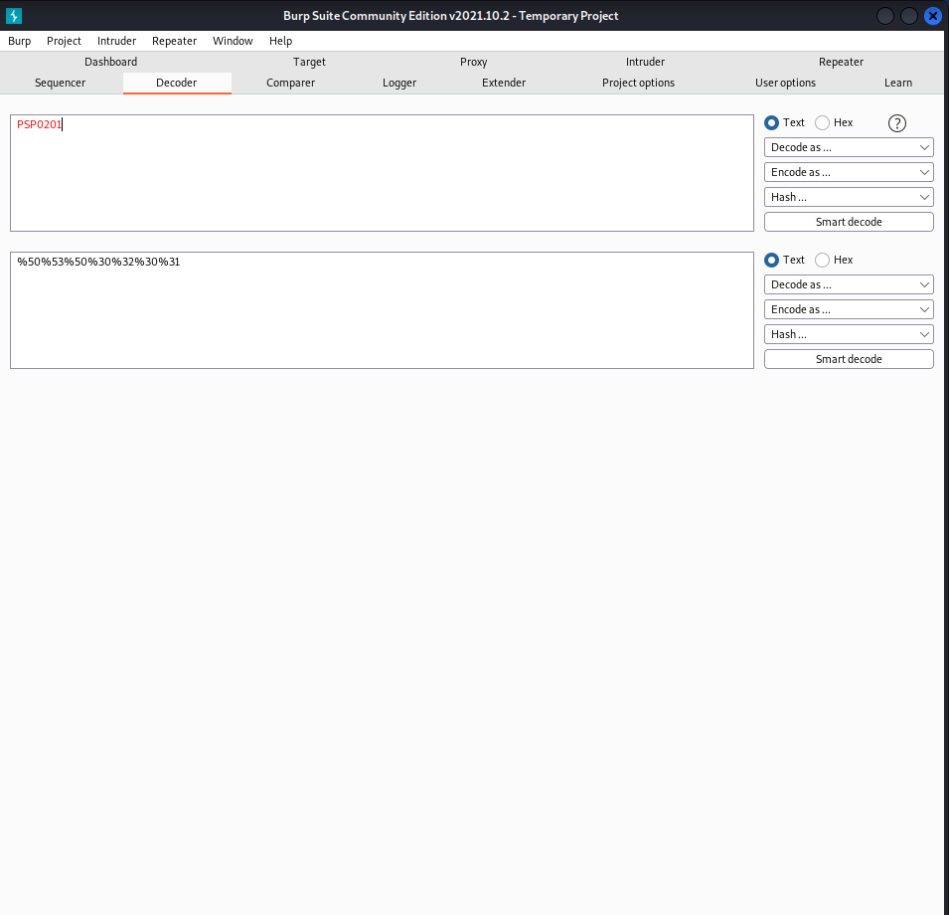

Q8: What is the flag?

A8: THM{885ffab980e049847516f9d8fe99ad1a}

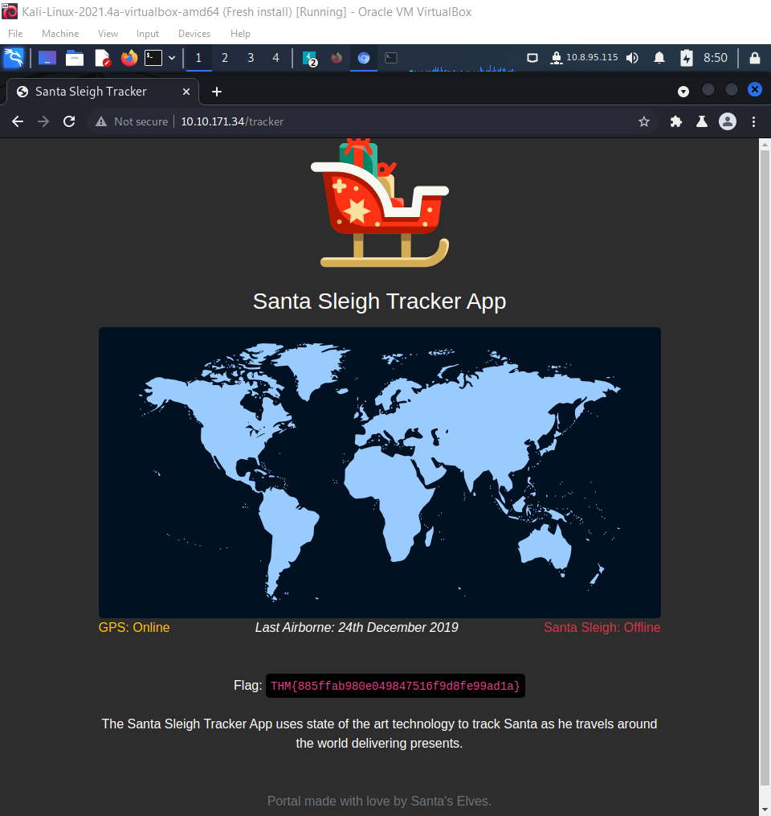

**Thought Process/Methodology:**

First, I access the target machine. I turn on the intercept in BurpSuite and randomly key in the username and password. I sent the intercepted username and password into the intruder. Then, I change the attack type to cluster bomb, key in the username and password which I would like to try, and start attacking. Afterwards, I get a list from payload 1 and 2. I find the correct username and password and login successfully. I get the flag in the end.

**Day 4: Web Exploitation - Santa's watching**

**Tools used:** Kali Linux, Chrome

**Solution/walkthrough:**

Q2: Use GoBuster (against the target you deployed -- not the [shibes.xyz](http://shibes.xyz/) domain) to find the API directory. What file is there?

A2: site-log.php

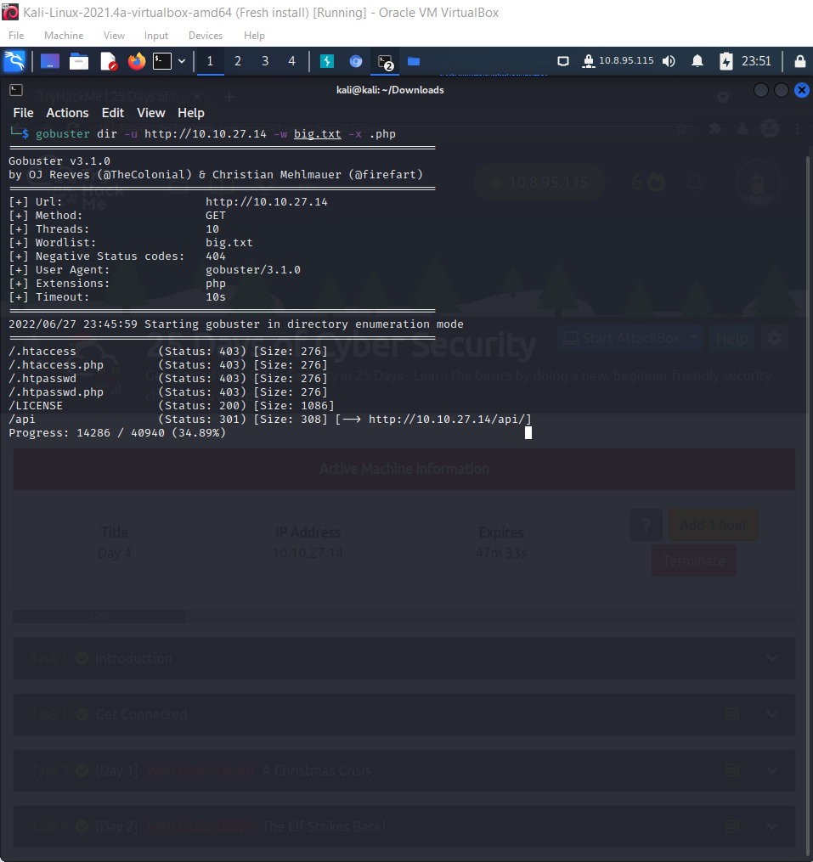

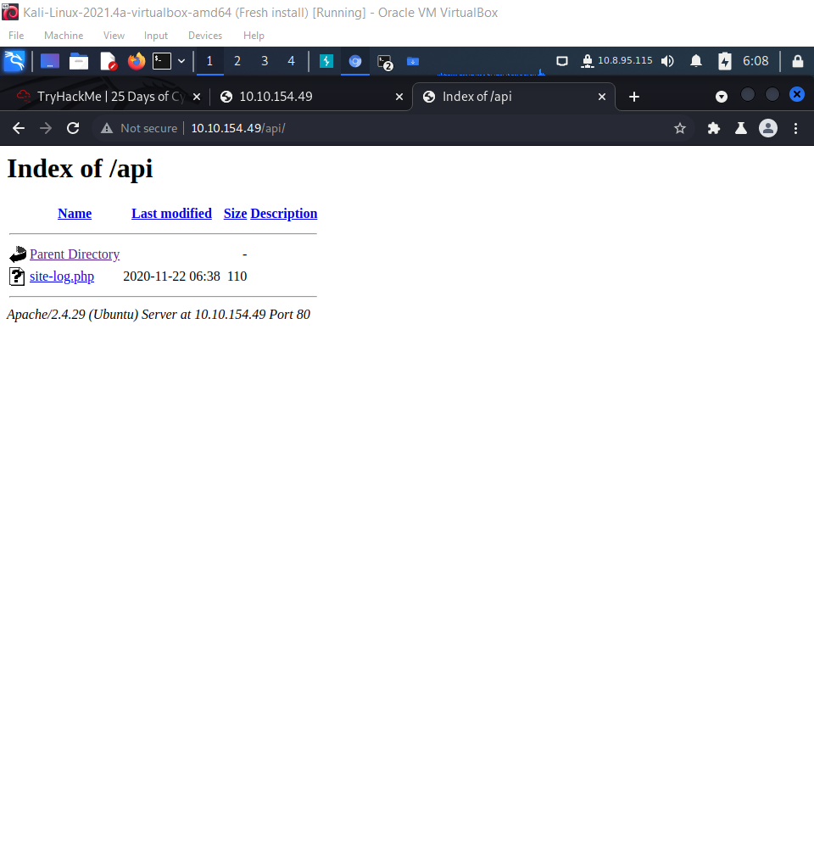

Q3: Fuzz the date parameter on the file you found in the API directory. What is the flag displayed in the correct post?

A3: THM{D4t3_AP1}

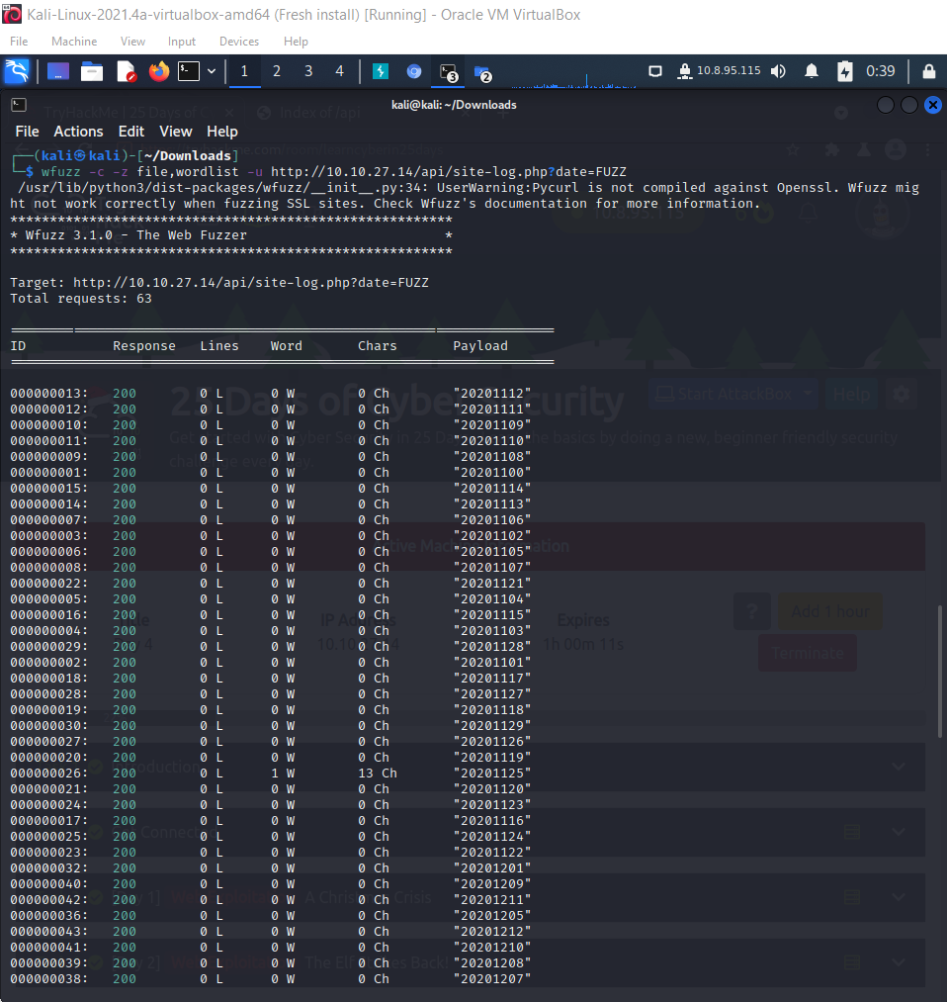

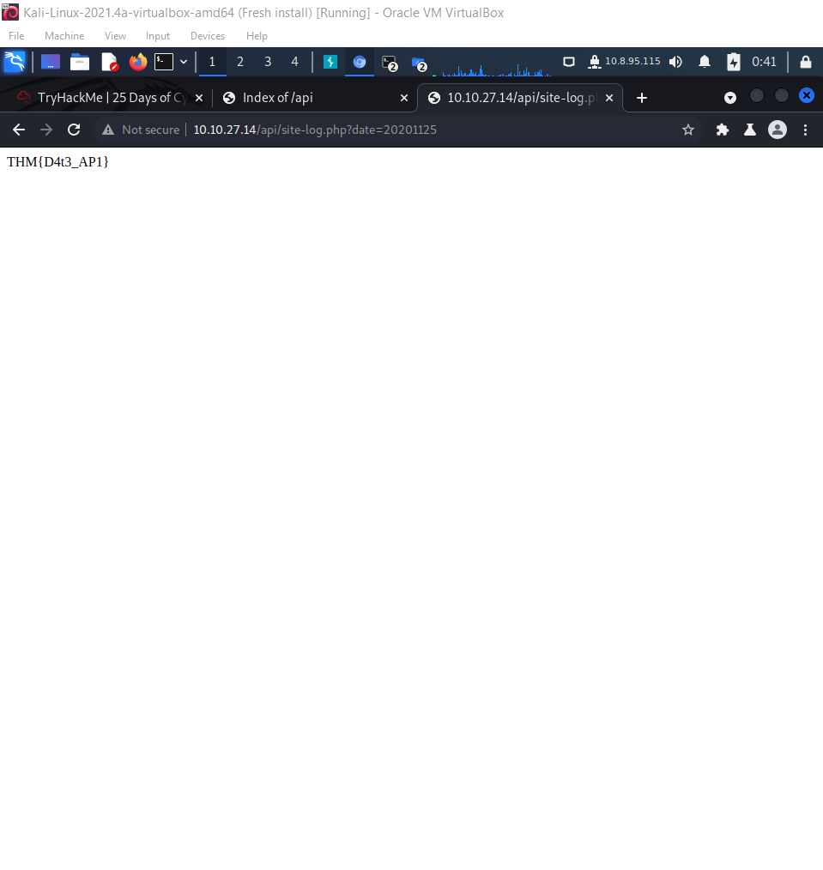

Q4: Look at wfuzz's help file. What does the -f parameter store results to?

A4: printer

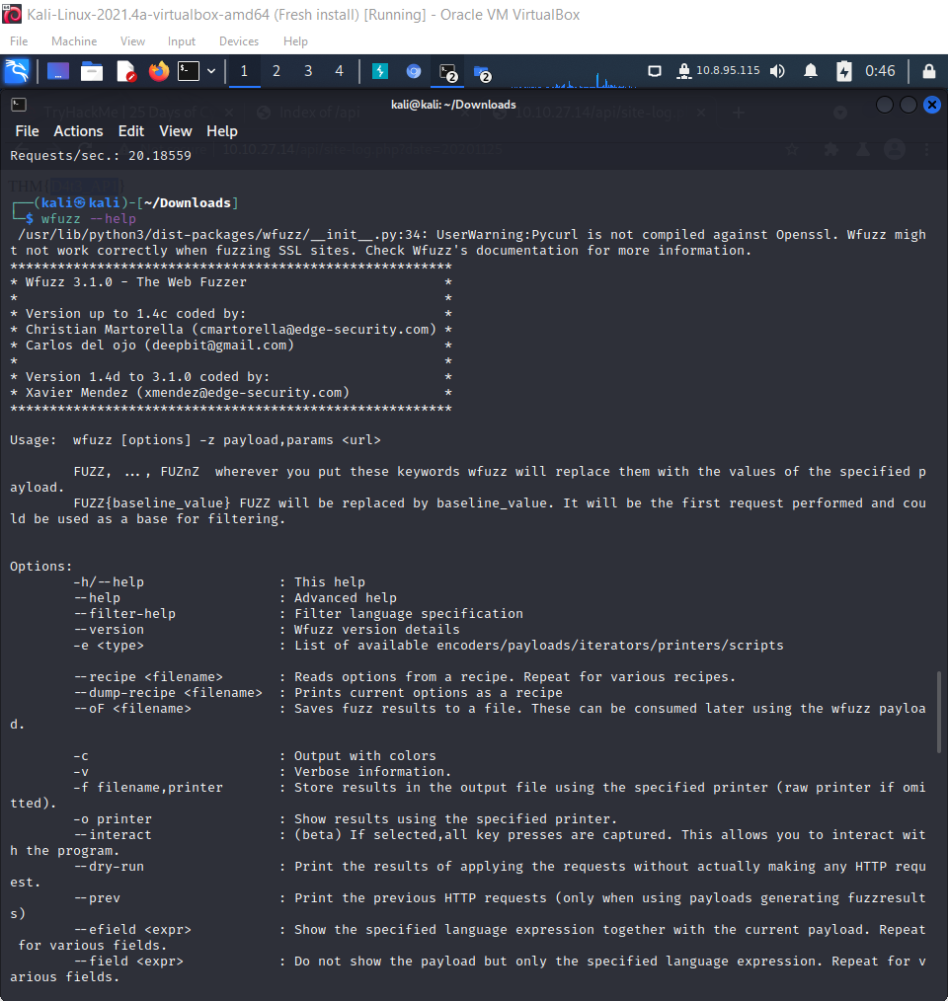

**Thought Process/Methodology:**

First, I download the big.txt from TryHackMe. Next, I open the terminal and key in ‘gobuster dir -u [http://MACHINE-IP] -w big.txt -x .php’. I get the information I need. Next, I open another terminal and key in ‘wfuzz -c -z file,wordlist -u http://[MACHINE-IP]/api/site-log.php?date=FUZZ’. I get the information I need. When I see a chars different char which is different from other chars, I apply the ID of the different char into ‘[http://[MACHINE-IP]/api/site-log.php?date=ID]’. I get the flag in the end.

**Day 5: Web Exploitation Someone stole Santa's gift list!**

**Tools used:** Kali Linux, Chrome

**Solution/walkthrough:**

Q1: What is the default port number for SQL Server running on TCP?

A1: 8000

Q2: Without using directory brute forcing, what's Santa's secret login panel?

A2: /santapanel

Q3: What is the database used from the hint in Santa's TODO list?

A3: sqlite

Q4: How many entries are there in the gift database?

A4: 22

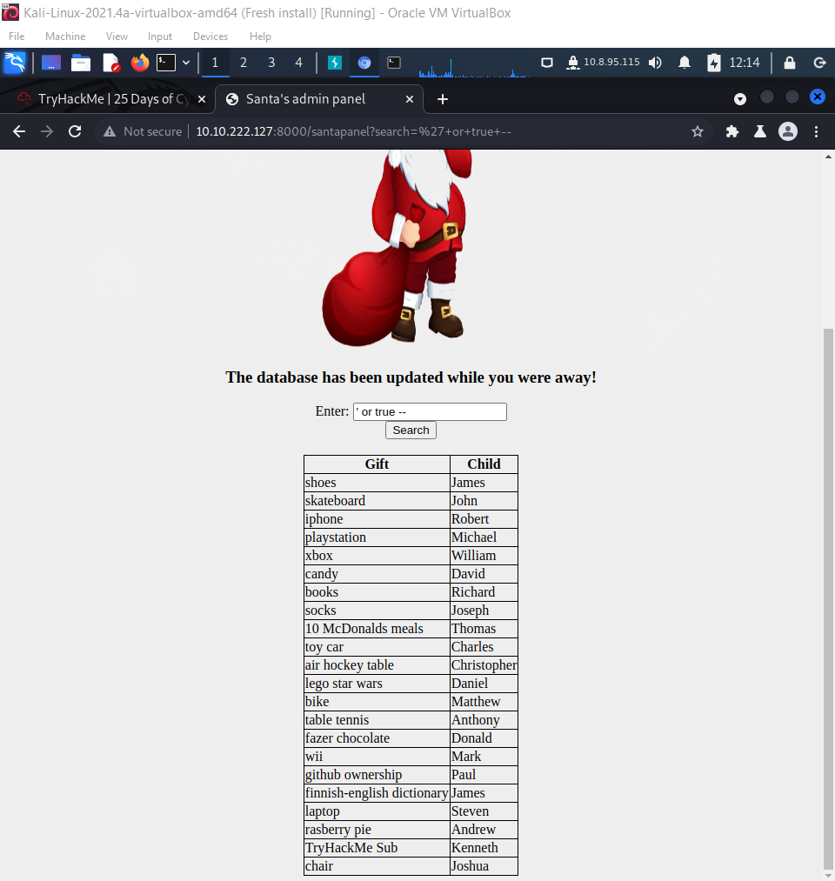

Q6: What did Paul ask for?

A6: github ownership

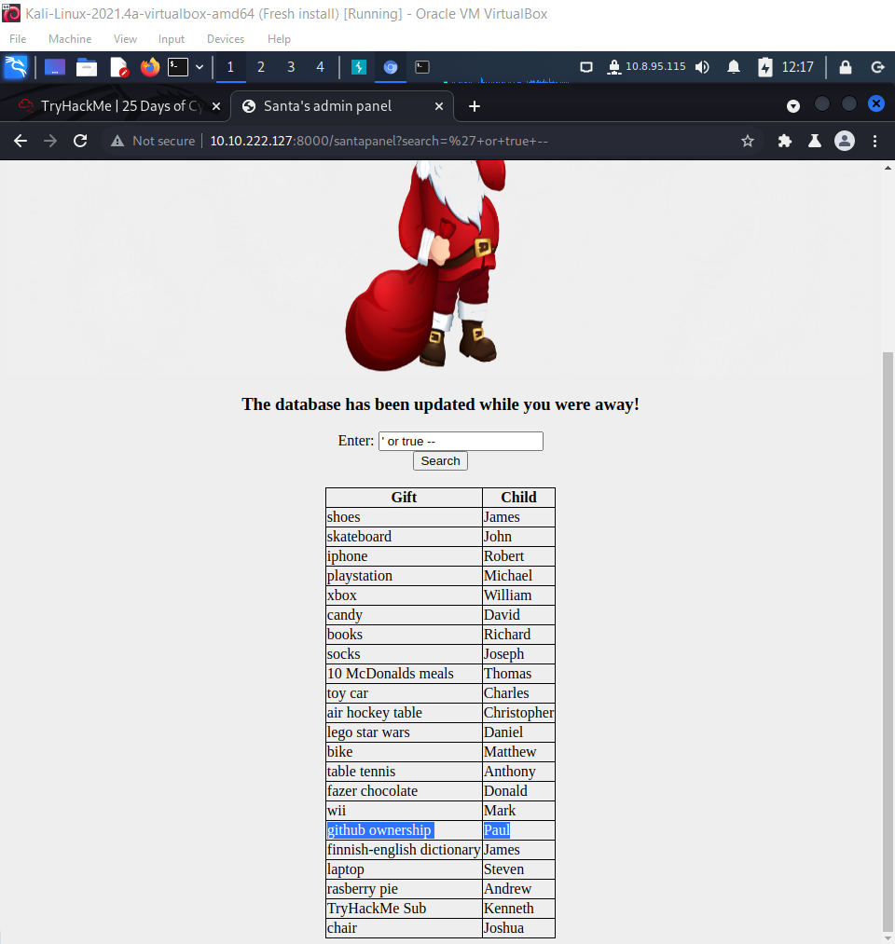

Q5: What is James' age?

A5: 8

Q7: What is the flag?

A7: thmfox{All_I_Want_for_Christmas_Is_You}

Q8: What is admin's password?

A8: EhCNSWzzFP6sc7gB

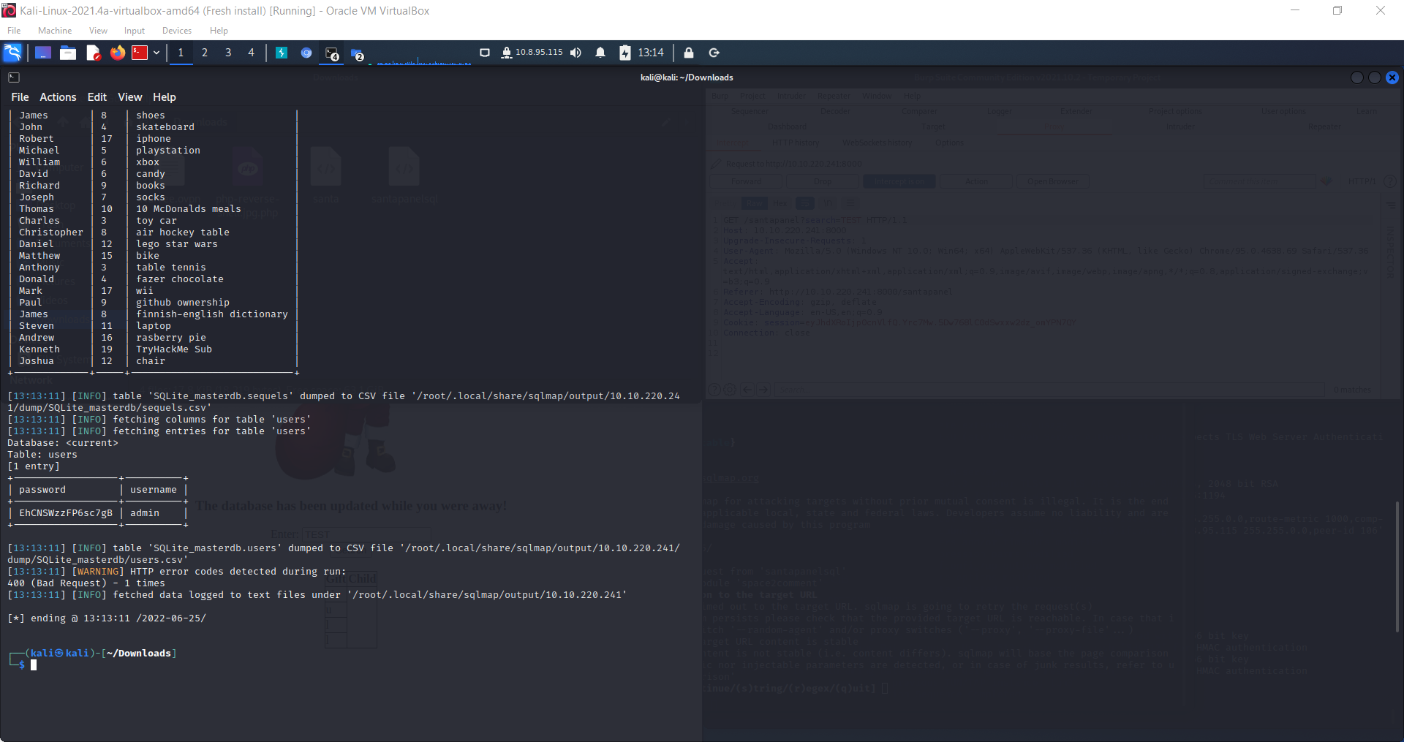

**Thought Process/Methodology:**

First, I log in into Santa’s account. I get the information I need.